**SNS NOTIFICATION**

**TOPIC:**

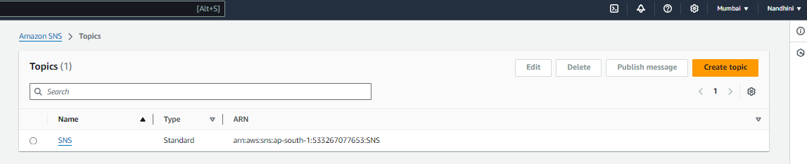

**Email Subscription:**

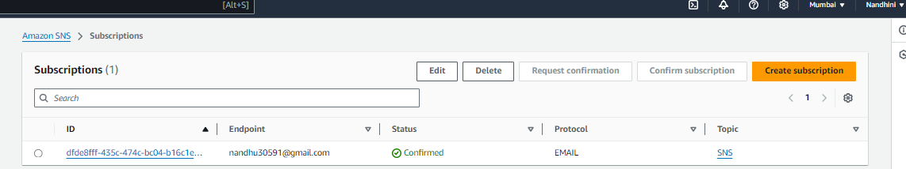

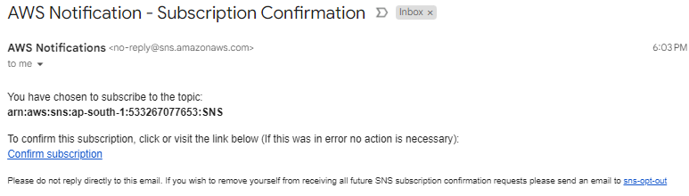

**Alarm Activated:**

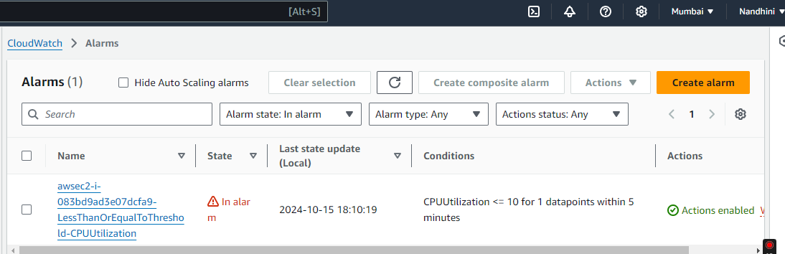

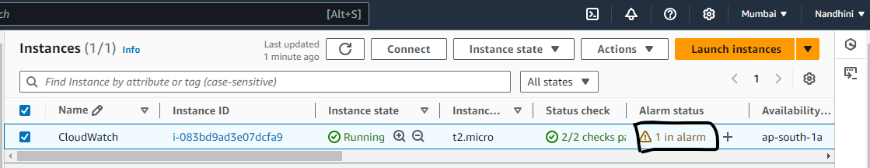

**Email triggered once the CPU threshold entered the Alarm state:**

